USEFUL THINGS

--------------------------------------------------------



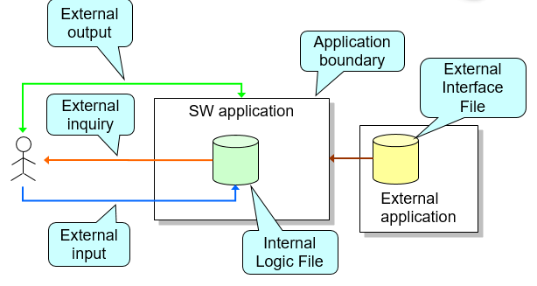

* Function types
  + **Internal Logical File (ILF):** homogeneous set of data used and managed by the application
  + **External Interface File (EIF):** homogeneous set of data used by the application but generated and maintained by other applications

**External Input**

* + Elementary operation to elaborate data coming form the external environment

**External Output**

* + Elementary operation that generates data for the external environment
    - It usually includes the elaboration of data from logic files

**External Inquiry**

* + Elementary operation that involves input and output
    - Without significant elaboration of data from logic files

Weighting function points (slides table)

|  |  |  |  |
| --- | --- | --- | --- |
| **Function types**   * N. Inputs * N. Outputs * N. Inquiry * N. ILF * N. EIF | **Weight** | | |
| **Simple**  3  4  3  7  5 | **Medium**  4  5  4  10  7 | **Complex**  6  7  6  15  10 |

Function points identification w.r.t. mTS

Data functionalities vs Transaction functionalities

**ILF**

The application stores information about

* Users (simple)
* Taxi Drivers (simple)
* SysAdmin (simple)
* Maps (simple, most of information is external in Google Maps)
* Reservations (simple)
* Queue (medium/complex)

**EIF**

The external interactions of the system are the following:

* Google Maps API (medium)
* Payment Services API (medium)

**External Inputs**

The external inputs of the system are the following:

* Customer login (simple)
* Customer logout (simple)
* Taxi Driver login (simple)
* Taxi Driver logout (simple)
* SysAdmin login (simple)
* SysAdmin logout (simple)
* Make a reservation (medium) // sys, res and cust involved
* Delete a reservation (medium) // as before
* Manage system manager (medium)
* … ?

**External inquiries**

* Customer requests information about his/her profile (medium)
* Customer requests information about his/her reservations (medium)
* Taxi Driver requests information about his/her next reservations (medium) (?)

**External outputs**

* Show the user the acknowledge of the reservation with details (hard) // several entities involved
* Show the maps on Taxi Driver’s GPS (medium)

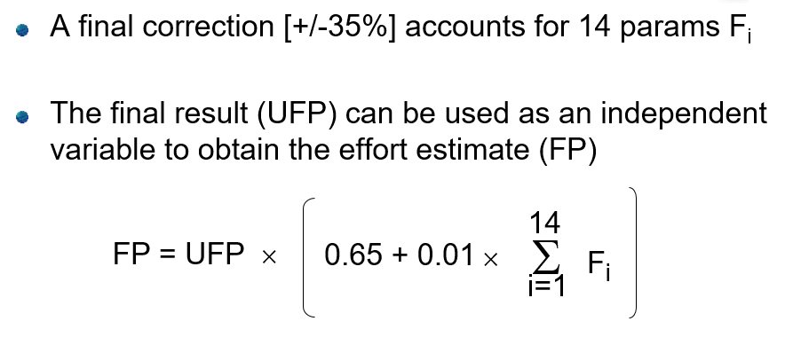

Fi standards

These 14 GSC are

1. Data Communication

2. Distributed Data Processing

3. Performance

4. Heavily Used Configuration

5. Transaction Role

6. Online Data Entry

7. End-User Efficiency

8. Online Update

9. Complex Processing

10. Reusability

11. Installation Ease

12. Operational Ease

13. Multiple Sites

14. Facilitate Change

**Function Point Estimation Worksheet**

|  |  |  |  |  |
| --- | --- | --- | --- | --- |
|  | Complexity | | |  |
| Description | Low | Medium | High | Total |
| Inputs | ___ x 3 | ___ x 4 | ___ x 6 | ___ |
| Outputs | ___ x 4 | ___ x 5 | ___ x 7 | ___ |
| Queries | ___ x 3 | ___ x 4 | ___ x 6 | ___ |
| Files | ___ x 7 | ___ x 10 | ___ x 15 | ___ |
| Program Interfaces | ___ x 5 | ___ x 7 | ___ x 10 | ___ |

Total Unadjusted Function Points (TUFP): _______________

(0=no effect on processing complexity; 5=great effect on processing complexity)

|  |  |
| --- | --- |
|  | 0-5 |
| Data communications | ___ |
| Heavily use configuration | ___ |
| Transaction rate | ___ |
| End-user efficiency | ___ |
| Complex processing | ___ |
| Installation ease | ___ |
| Multiple sites | ___ |
| Performance | ___ |
| Distributed functions | ___ |
| On-line data entry | ___ |
| On-line update | ___ |
| Reusability | ___ |
| Operational ease | ___ |
| Extensibility | ___ |

Processing Complexity (PC): ______

Adjusted Processing Complexity (PCA) = 0.65 + (0.01 * ____________)

Total Adjusted Function Points (TAFP): ___________ * ____________ =